Hello,

I’m Yadvendar Singh from the KPMG Data Analytics (Virtual Internship) team. I received data provided by your company Sprocket Central Pty Ltd, for reviewing the data quality to ensure that it is ready for analysis. Our Data Quality analysis evaluates a dataset based on the below-mentioned dimensions.

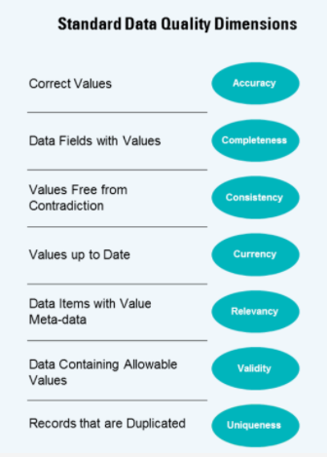
Fig: Data Quality Dimensions

We performed the analysis on the following datasets, as provided by your team:
- Transaction Data
- Customer Demographic
- Customer Address

A detailed report of each dataset has been generated and presented below in this report.
The provided Transactions dataset tells us about the Bicycle transactions made from 2017-01-01 to 2017-12-30 by Sprocket Central Pty Ltd.

Here is an overview of the Transaction dataset:

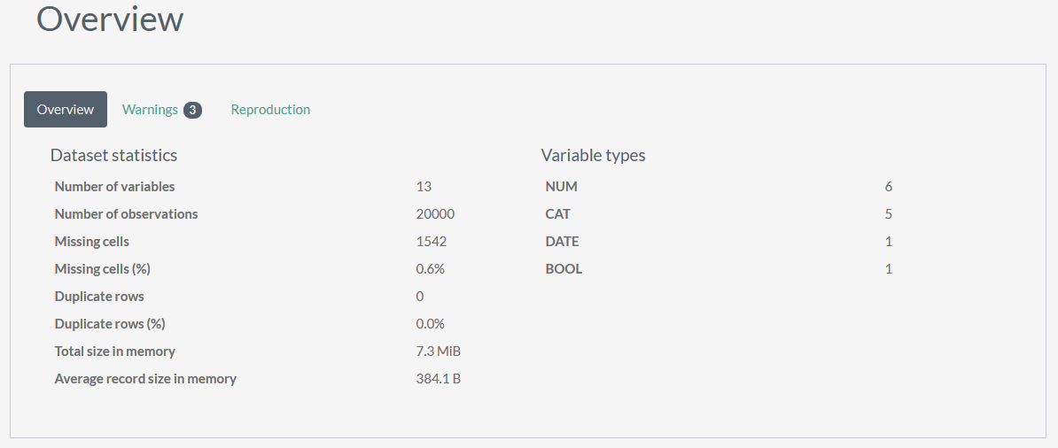
Fig: Overview

- Dataset Statistics tells us that there are 13 attributes that contain 20,000 values.
- 1542 cells were missing information which accounts for 0.6% of total values.

Furthermore, analysis of each attribute in Transactions dataset gives us a better understanding of how to properly maintain the data so that it can be utilized for analysis purposes.

Attributes of Transaction Dataset
Below mentioned attributes in Transactions dataset couldn’t perform well on our Data Quality Dimensions. Each attribute is provided with a approach to rectify the errors in the dataset.

- online_order

This attribute has categorical values True and False. True means the purchase has been made online, and False means the purchase has not been made online.

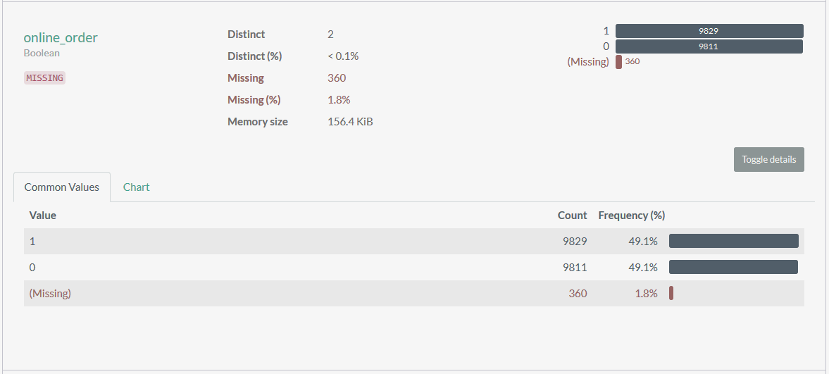
Fig: online_order report

- This attribute contains 360 missing values which accounts for 1.8% of total values and fails on our Completeness parameter. Values need to be updated for gaining insights from the data.

Correction Required:
Yes

Potential Solutions:
- We can fill in the missing values based on the behavior of same product_id, and list_price of other transactions.
- We can fill in the missing values based on customer behavior using customer_id. If his/her orders are mostly online then we can replace the missing value by True, if not then by False.
- If we cannot find any correlation between the values, then we can drop the specific row.

- brand

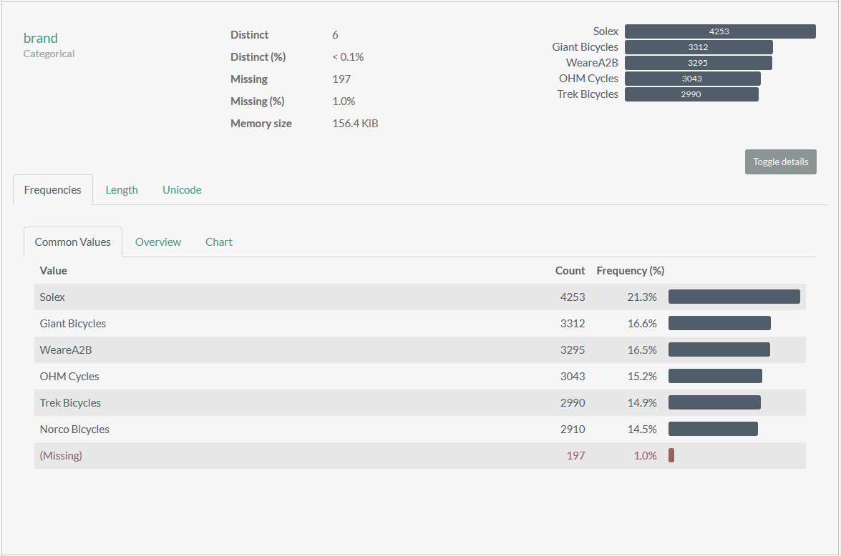
Fig: brand report

- brand attribute contains 197 missing values and fails on our Completeness parameter.

Correction Required:
Yes

Potential Solutions:
- 197 values that are missing corresponds to product_id 0, and misses product_line, product_class, product_size, standard_cost, and product_first_sold_date.
- We can drop the missing brand values, as values that brand correlated with most are also missing.

- product_line

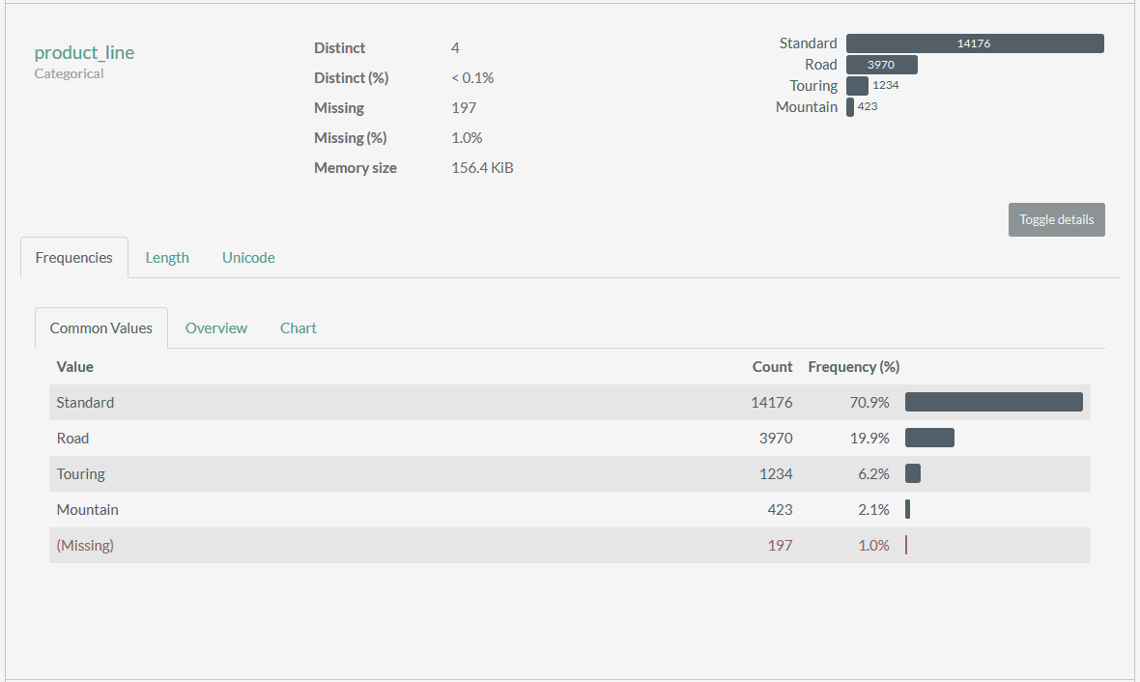
Fig: product_line report

- product_line attribute contains 197 missing values and fails on our Completeness parameter.

Correction Required:
Yes

Potential Solutions:
- These 197 missing values corresponds to the same 197 missing brand values. Dropping the former missing values will fix this issue.

- product_class

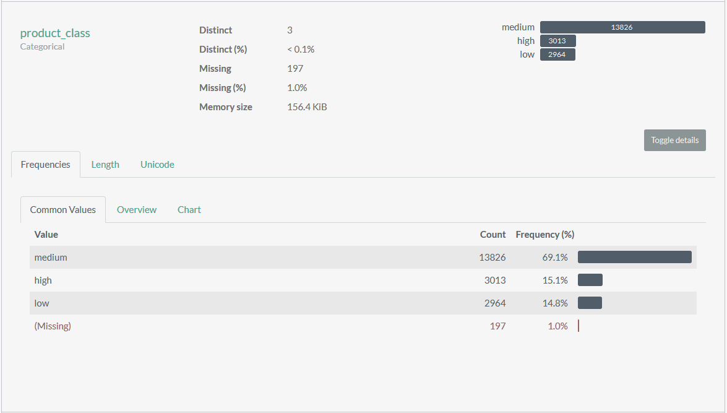
Fig: product_class report

- product_class attribute contains 197 missing values and fails on our Completeness parameter.

Correction Required:
Yes

Potential Solutions:
- These 197 missing values corresponds to the same 197 missing brand values. Dropping the former missing values will fix this issue.

- product_size

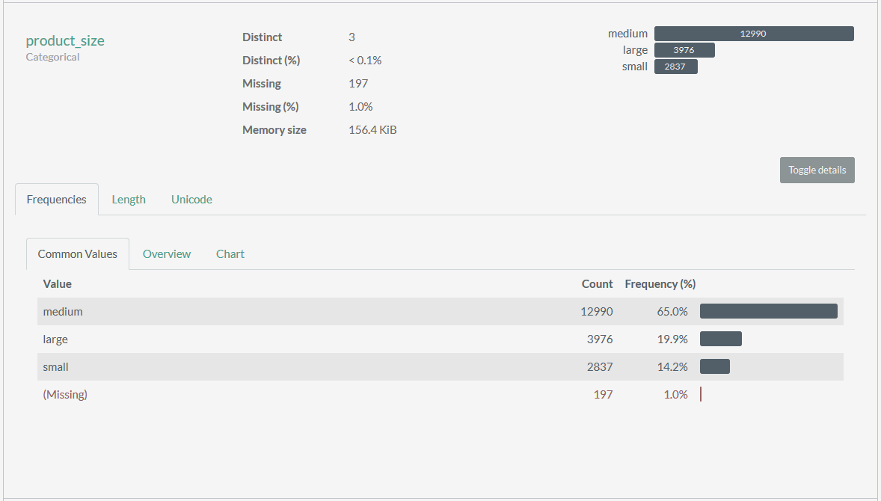
Fig: product_size report

- product_size attribute contains 197 missing values and fails on our Completeness parameter.

Correction Required:
Yes

Potential Solutions:
- These 197 missing values corresponds to the same 197 missing brand values. Dropping the former missing values will fix this issue.

- product_first_sold_date

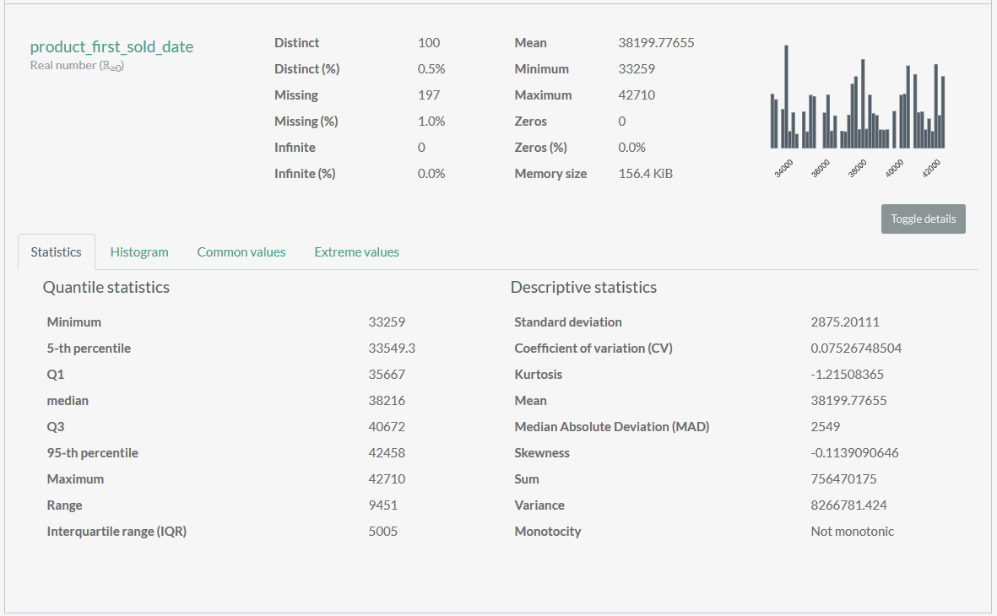
Fig: product_first_sold_date

- Product_first_sold_date is not maintained in proper datetime format and fails on our Validity Parameter.

Correction Required:
Yes

Potential Solutions:
- Convert the type of attribute to datetime to fix the issue.

Complete report of Transaction dataset can be accessed from here: Transactions Data Quality Report

Customer Demographic dataset allows us to understand background characteristics of our customers, whether it’s their age, race, ethnicity, income, work situation, marital status, etc.

Here is an overview of the Customer Demographic:

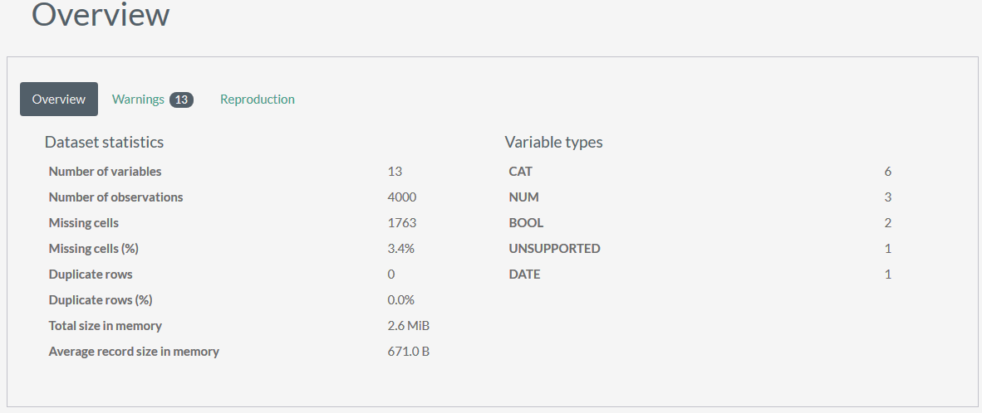
Fig: Overview of Customer Demographic

- The dataset contains 13 attributes and 4000 values.
- 1763 values are missing, which accounts for 3.4% of total values.

Attributes of Customer Demographics
Below mentioned attributes in Customer Demographics dataset could not perform well on our Data Quality Dimensions. Each attribute is provided with a approach to rectify the errors in the dataset.

- last_name

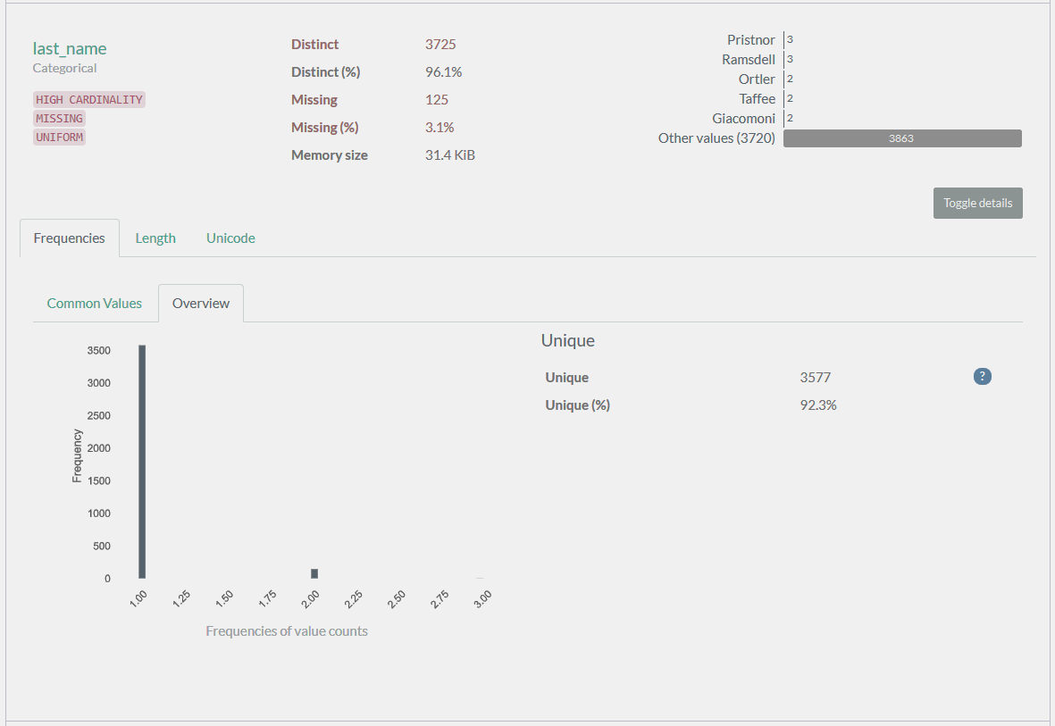
Fig: last_name report

- last_name has 125 missing values which accounts for 3.1% of total values and it fails on our completeness dimension.

Correction Required:
Yes

Potential Solutions:
- We can replace the values based on a common last_name or by assigning the same last_name.

- gender

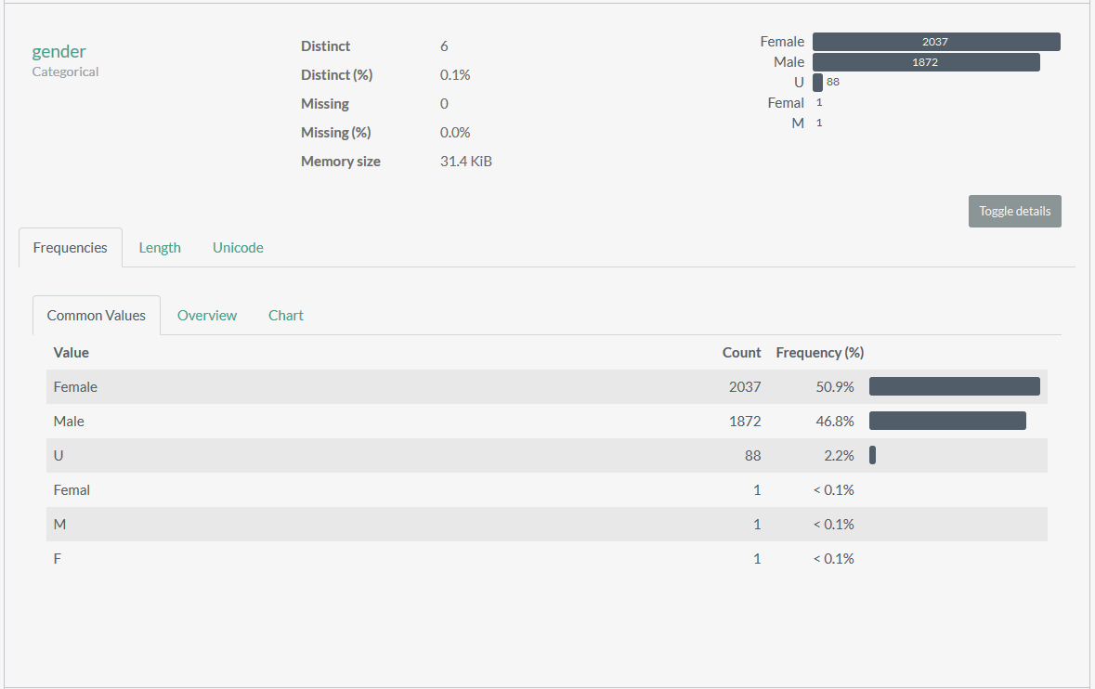
Fig: gender report

- This attribute fails on our Validity Dimension, as it contains values which are not allowed, and cannot be identified.

Correction Required:
Yes

Potential Solutions:
- We can replace the “Femal” to “Female”, “M” to “Male” , “F” to “Female”, and “U” to “Unidentified” for the people who don’t identify themselves as either “Male” or “Female”. This will bring uniformity in th data.

- DOB

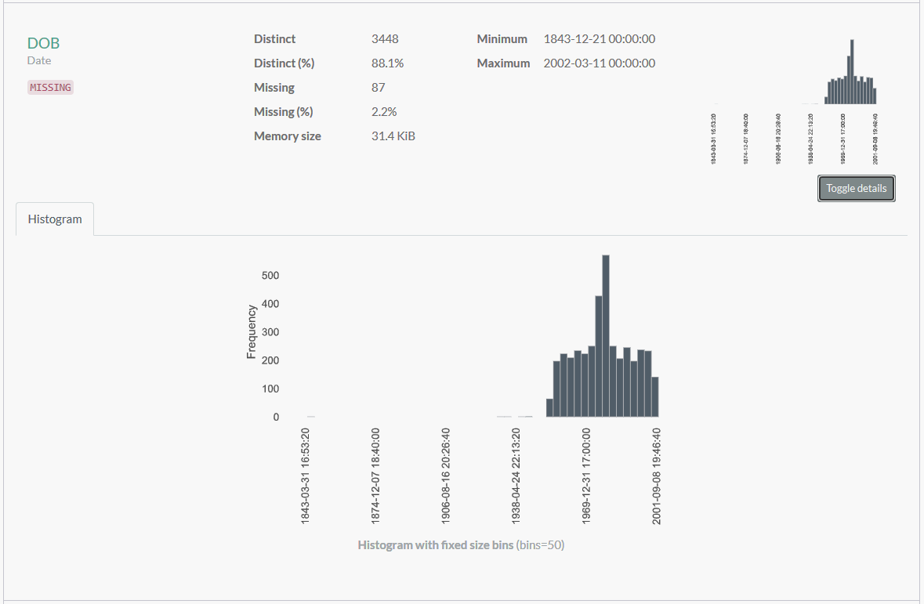
Fig: DOB report

- This attribute fails on our Consistency Parameter, as there is a DOB “1843-12-21” which makes the age of the person 177 years, which is scientifically not possible.This attribute also fails on Completeness parameter as it is missing 2.2% of the values.

Correction Required:
Yes

Potential Solutions:
- We can replace the missing and wrong values with dataset mean/median.

- job_title

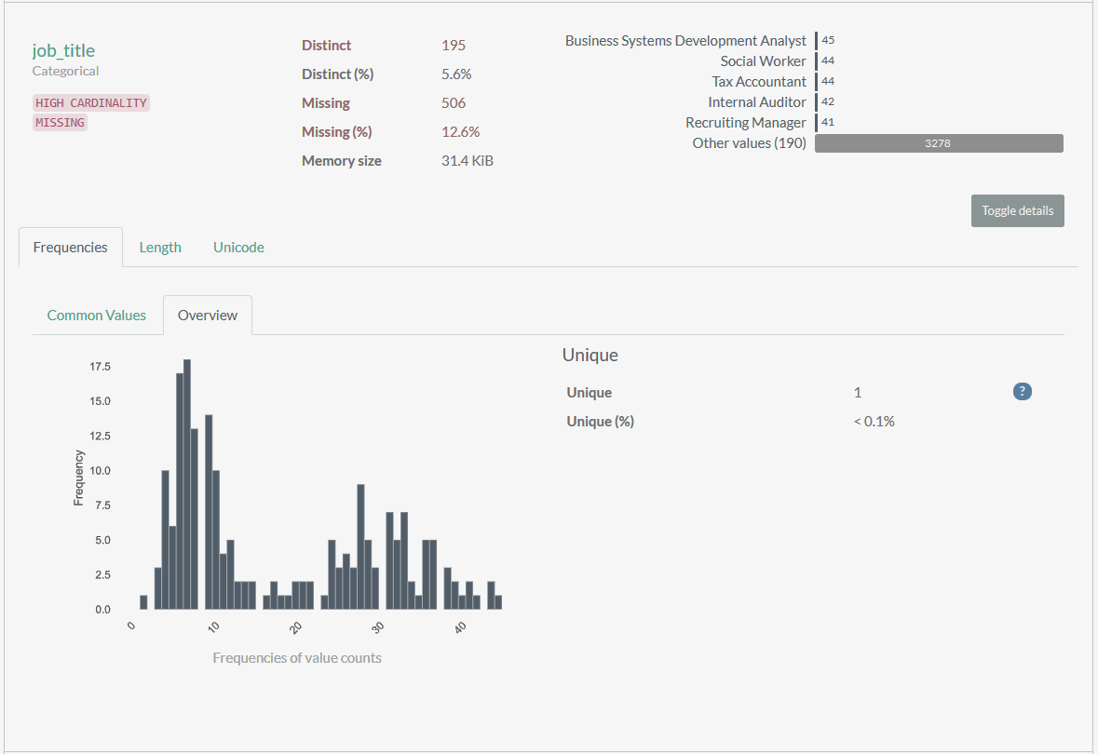
Fig: job_title report

- This attribute fails on our Completeness parameter, as it is missing 12.6% of total values.

Correction Required:
Yes

Potential Solutions:
- We can replace the missing job title based on same job_industry_category and same wealth_segment of other customers.

- job_industry_category

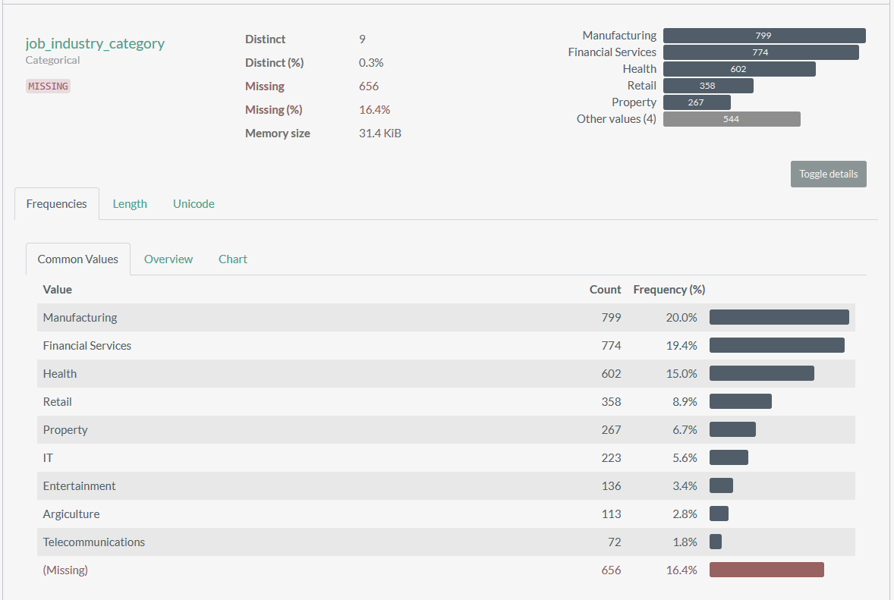
Fig: job_industry_category report

- This attribute fails on our Completeness parameter, as it is missing 16.4% of total values.

Correction Required:
Yes

Potential Solutions:
- We can replace the job_industry_category based on same job_title, same gender, and same wealth_segment of other customers.

- default

- This attribute fails on all dimension as it is missing values and has unsupported data type which could not be apprehended.

Correction Required:
Yes

Potential Solutions:
- We can drop this attribute.

- tenure

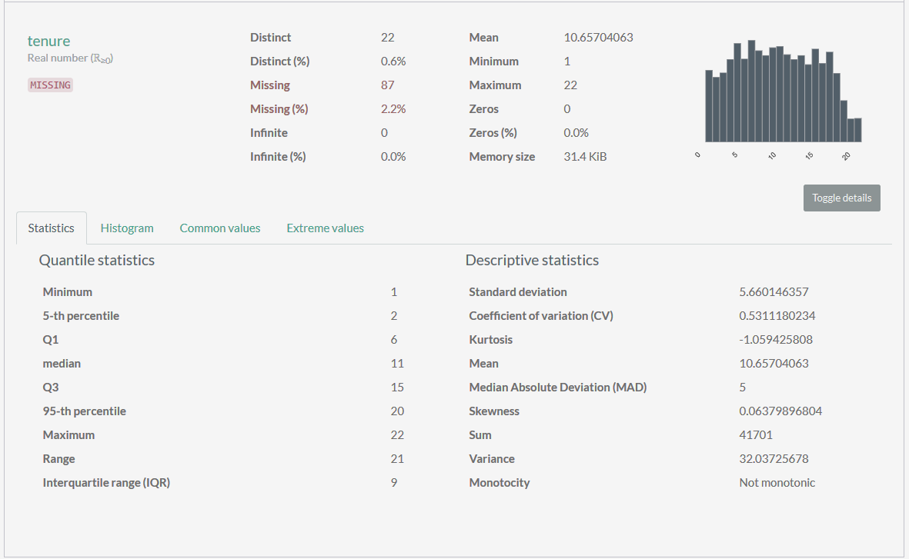
Fig: tenure report

- This attribute fails on our Completeness parameter, as it is missing 2.2% of total values.

Correction Required:
Yes

Potential Solutions:
- We can replace the missing values based on mead/median of the dataset.

Complete report of Customer Demographics dataset can be accessed from here: Customer Demographics Data Quality Report

Customer Address dataset allows us to understand the locality of our customers to make their purchasing journey smooth as possible.

Here is an overview of the Customer Address:

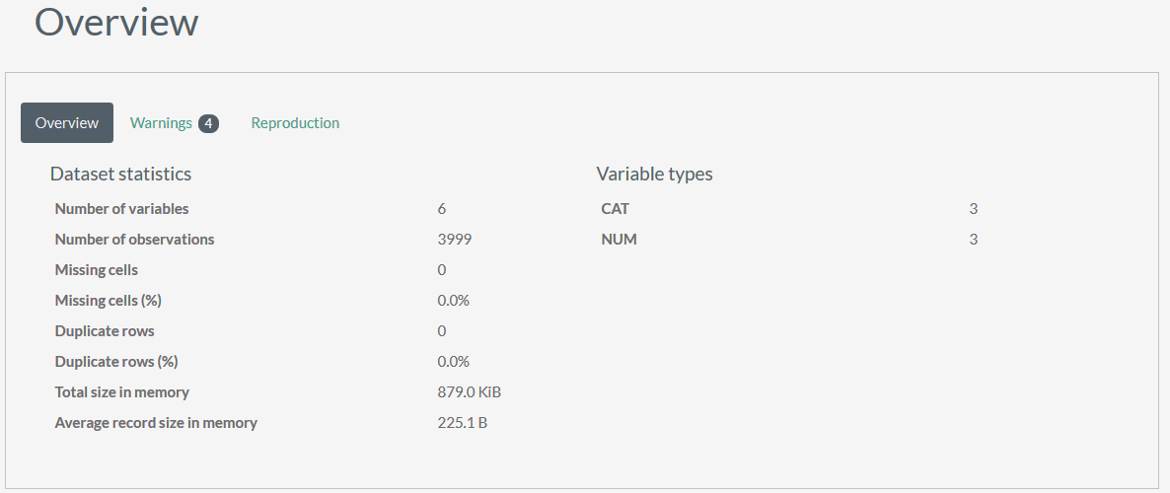
Fig: Customer Address report

The dataset is properly curated and needs no change.

Complete report of Customer Address dataset can be accessed from here: Customer Address Data Quality Report.

The team will continue with data preprocessing, standardization, and transformation process for the analysis purpose. Any further questions and assumptions will be documented and forwarded to you. After we have completed this, it would be great to spend some time with your data SME to ensure that all assumptions are aligned with Sprocket Central’s understanding.

Kind regards,
Yadvendar

